**Lab 11: Using OllyDbg to Analyze Lab09-01.exe**

**Course Name**: Malware Analysis and Reverse Engineering (IAM302)

**Student Name**: Nguyễn Trần Vinh – SE160258

**Instructor Name**: Mai Hoàng Đỉnh

**Lab Due Date**: 22/2/2023

**What You Need**

* A Windows machine, real or virtual. I tried this on Windows 7, 10, and Server 2008 and it works on them all.

**Purpose**

* This is just the beginning of Lab09-01, performing the first run-through. This analysis shows that if the code is executed as it is, it checks for a certain registry key, and if that key is absent, it deletes itself

**Get OllyDbg 1.10**

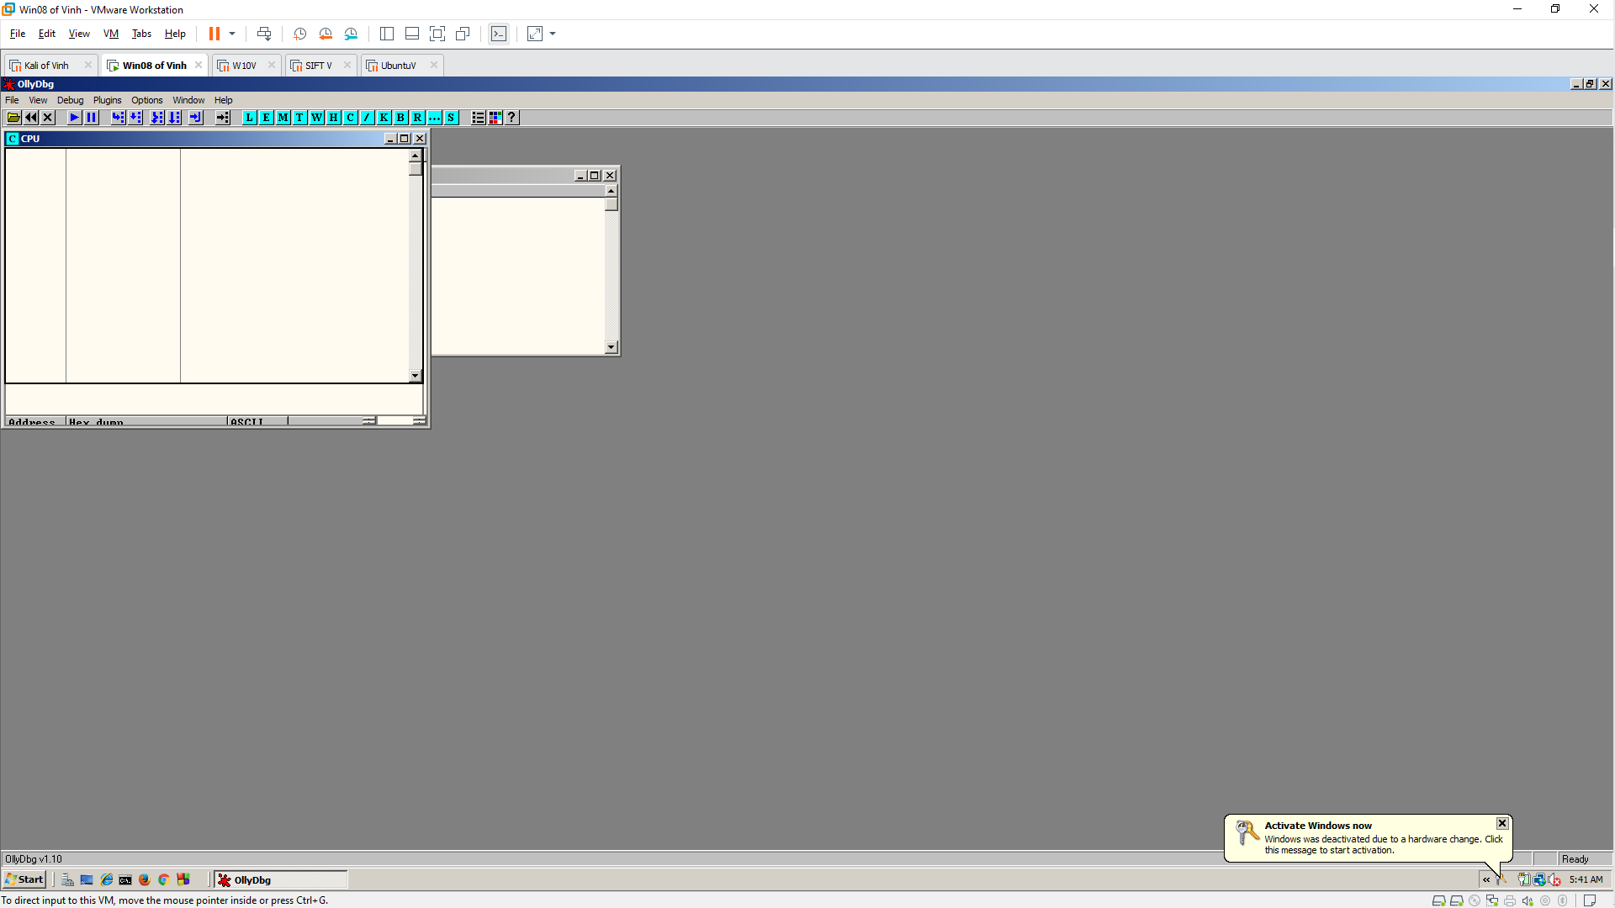

**Finding the Main Entry Point**

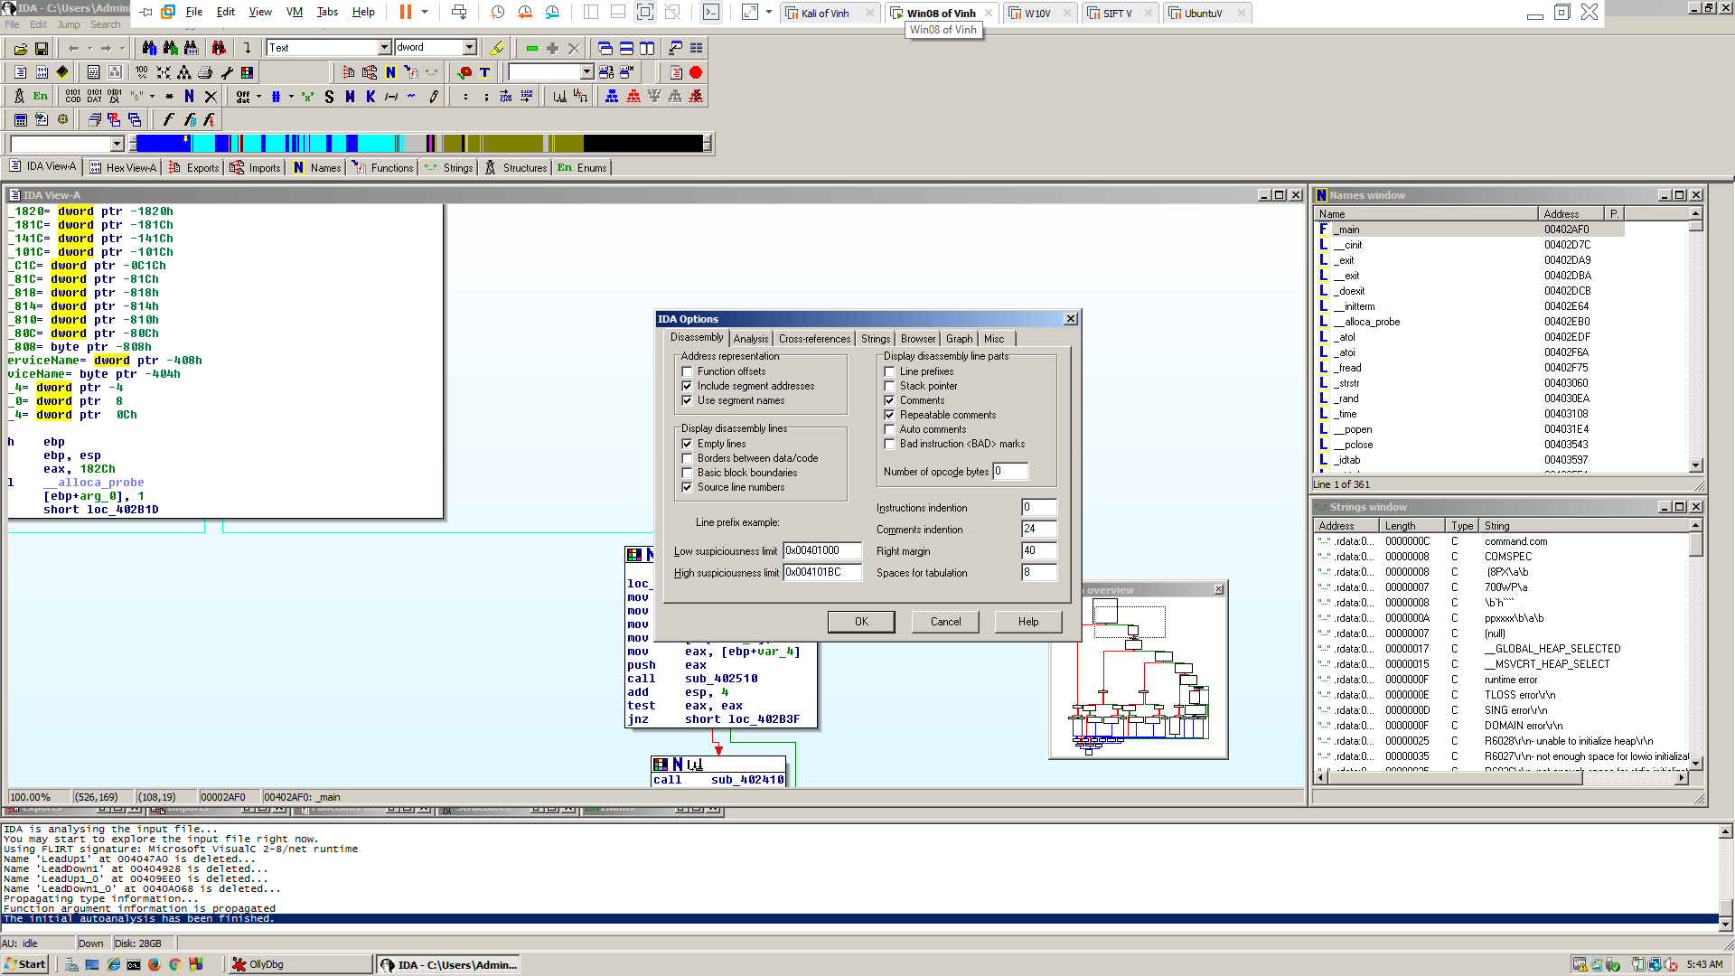

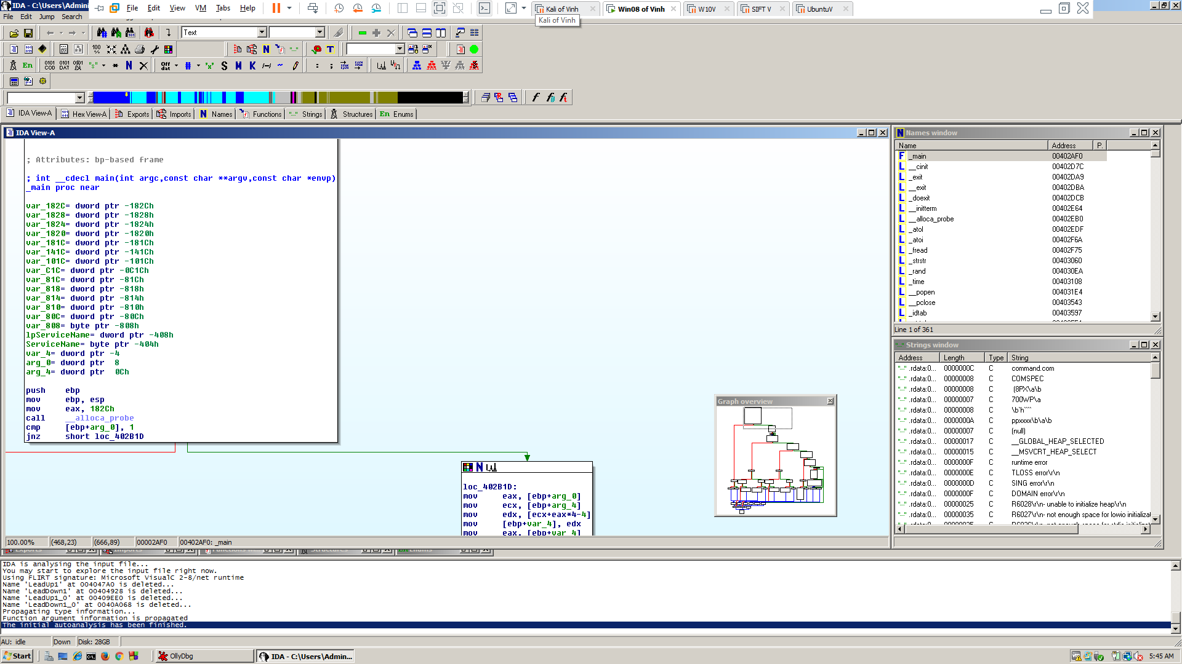

**Using OllyDbg to Walk Through Quickly**

